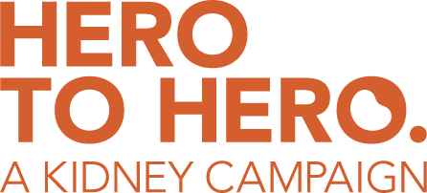
EMAIL TEMPLATE
Dear XXX,
As you know, I am a very proud member of the Board of Directors of the National Kidney Foundation of Arizona. I joined the board because…. (please share your reasons for joining the board, including any personal or kidney connection that you feel comfortable to share)
We have been engaged in a comprehensive fundraising campaign, The Hero to Hero Campaign for the last several years and I’m happy to report that we are very close to reaching our goal!
With that, we are publicly reaching out to our friends in the community to let them know about our recent success, and the plans that we have in the works. We are currently at 75% of our goal, and this is the perfect time for everyone in the community to be a part of this campaign and help us get over the finish line! I’m hoping that you’ll share in my enthusiasm and join us in this effort.
Below, I have included a link that will take you to the Hero to Hero Campaign website that explains what we are raising money for, the programs we are looking to bolster and create, and of course, all of the different ways that you can give.
Just visit: www.azkidney.org/hero
Thank you so much in advance.
Best wishes,
[your name]
P.S. All gifts to the National Kidney Foundation of Arizona qualify for the Arizona Charitable Tax Credit, so by making a donation you can make a real difference—at no cost to you. When you give, you earn a dollar-for-dollar credit against your Arizona state taxes—up to $470 if you file as a single, $938 if filing jointly. This means your donation today comes right back to you in the spring.

