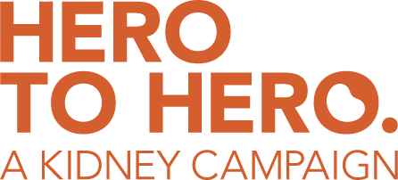

SOCIAL MEDIA SAMPLE CAPTIONS
1.
Join me in an effort to help your neighbors in need!
The National Kidney Foundation of Arizona, of which I am a proud board member, is launching a campaign to lift the burden of chronic kidney disease. More than 1 in 7 Arizonans have it and 90% of them have no idea.
This holiday season, will you be a hero and help us reach our goal to provide medications, transportation to dialysis, and a whole host of other vital patient services? Your gifts are tax deductible for you…. and life-saving for so many others.
Please visit azkidney.org/HERO to donate and learn more today. Doing right never felt so good!

2.
Did you know that kidney disease does not just attack older Arizonans?
Children of any age can be stricken by this debilitating disease, and the kids in our state are affected more than many other regions of the country.
The National Kidney Foundation of Arizona, of which I am a proud board member, is launching a campaign to not only lift the burden of this chronic disease, but also create an environment where these children can forget about their troubles, and just have a weekend to have fun. The campaign support programs like Camp Kidney, and this holiday season, you can be a hero for these children in need.
Will you help us reach our goal and brighten a child’s life? Please visit azkidney.org/HERO to make your Arizona State Tax Credit qualifying gift today!

3.
You don’t need to win the lottery to make a huge difference in the lives of your neighbors! In fact, you can save a life without it even costing you a dime.
The National Kidney Foundation of Arizona, of which I am a proud board member, is launching a campaign to lift the burden of kidney disease in Arizona. And because of the Arizona Charitable Tax Credit, you can donate up to $470 if you are single, and $938 if you file as a married couple, and you will get every dollar back in your tax return.
You can be the hero your community needs and get that credit right back in the spring. It’s really that easy. Please visit azkidney.org/HERO to donate or learn more today!

4.
This season, we all have a lot of difficult choices to make, but here’s one that is easy and will actually make you feel great!
The National Kidney Foundation of Arizona, of which I am a proud board member, is launching a campaign to lift the burden of kidney disease in Arizona. It is a debilitating disease that hits 1 in 7 people in Arizona. In fact, each year, it kills more people than breast cancer or prostate cancer. And amazingly, 90% of people who have it have no idea.
We are the agency of last resort for adults and children battling this disease. We provide support for patients with no hope. We are so close to our goal of sustaining our direct patient aid programs for years to come. Will you be your neighbor’s hero this holiday season? Please visit azkidney.org/HERO to make your Arizona Charitable Tax Credit qualifying gift today!

